Sh.Ch. walikhanov
Diary of a journey to Kulja
1856. August 2

August 2

From Borokhudzhir to the Usek River, there is a sandy bare steppe, hilly near Borokhudzir, which turns to a plain at the third piquet that goes as far as [17] Kulja. The soil is clayey and consists of loose layers of clay and small debris. The water flow and spring shows have brought down these hills and formed pits and ditches. There is no vegetation in the steppe, except for ysai (small wormwood), wormwood, mugwort, ebelek [tumble grass], and salt tree. Near the river, the vegetation was more diverse: we saw the giant bushes of Chinese cannabis [a species of wild cannabis] and cheegrass on the bank of Borokhydzhir. It seems that only lizards and snakes ruled in these places. The former had many species, were green and ran fast, the latter, short-tailed, glide everywhere underfoot. As for birds, we saw only larks and the steppe species of hazel grouses.

The day was hot and windless, and the sun heated the earth so that we could not step. In such steppe and such heat, we passed 25 versts until we reached the first canal from the river Usek. Tired and exhausted by the heat, we used the shadow of several grey willows growing there with special pleasure and rested waiting for the camels who followed us. We went straight to Usek, leaving the Chinese piquet №3 to the right behind the ravine.

The Chinese officers accompanying us also stopped, but chose the solon's hut as a place for rest, where, as they told later, they managed to eat some onion and drink their stinking vodka - ju, of course, at the expense of the host. Having finished their meal, they, apparently, to the great joy of the poor soldier, who was paid for a cup of sour milk without compensation, came to us and offered to make a stop at Usek, which, according to their assurances, was only 3 versts away. Since water in the canal was muddy, and there was no food for the horses, we, of course, with great reluctance, got onto our horses, and, trusting in Allah, exposed our heads to the burning rays of the Chinese sun again.

A similar [18] exhausting journey looks strange and pathetic. The hourses, having hung their heads, walked in short steps; the riders hung sadly, and, having loosened the reins, thought God knows what. Fatigue and unwillingness were equally noticeable in people and livestock. Our Chinese acted here according to the rules of etiquette as well. and arranged a procession headed by a thin solon armed with a bow and arrows, who performed a duty of a permanent din-ma [A deformed Chinese word. Here it means a spy], a nail-man. Sirs officials were aimlessly sitting on their chair-wide saddles and smoking their copper ganzas [A mouthpiece, hookah, pipe for smoking]. Black cloth made of coarse daba [cotton hand-made fabric of different colors]… was already used by them as a hat; put on a head like a pancake, like the Imeretians wear papanaks, it was entwined with a braid so that it would not fall, and in front the, the edges hanging over the forehead cast a large shadow…

And here, the steppe was also bare and sandy. Only along the stream course, there were some trees, which made us very glad, and we imagined that in their shade, we would find some peaceful rest, but alas! We found out that we could not stop at Usek for lack of food. And indeed, there was sand and cobbles everywhere, not a single grass blade; even a heavy reconnaissance survey did not help us to find a clean place to set up a yurt. However, we decided to stop here under the trees and refresh ourselves, i.e. our stomachs, a bit.

In pleasurable anticipation of the upcoming dinner, I went to the river for a swim, and people began to make tea and snacks. Despite this, I was so thirsty that I lost my last patience and began to drink even warm kumis. My thirst increased even more; I tried to chill the drink and ordered to tie the wineskin to a branch and lower it into the river. I drank kumis with water, but it was all in vain. At last, the expected tea was served. This Chinese leaf is an amazing and irreplaceable drink in hot time; nothing, absolutely nothing, can quench your thirst like tea. Thank Allah! We relieved our feelings! And calmed ourselves so much that we were able to drink vodka and eat Chinese duck, which, along with several chickens and cucumbers they bought on the way from the solon farmer. [19] The heat was so intense that one of our birds laid an egg right there on the sand.

While we were spending time under a willow bush and having our travel meal, the camels managed to cross the river and directed towards the river Burkhan-su rich in food and water. It was high time to get onto our horses again. Refreshed with tea, we cheerfully mounted our horses and rode off quickly. The steppe from Usek begins to change. The vast space opens dotted with forests; to the right, there was Ily, and in front of us, the low sandy valleys appeared blue. It is strange that here, wherever water flows, vegetation appears and intensifies. Except for salt tree and goatsbeard, there are rather high grey willows and dzhigidovnik along the Usek, and a little farther along the canals, we began to meet beautiful elm trees with emerald green leaves and barberry. The farther we went, the more the steppe livened up: its sad and lifeless character was softened by the greenness of the trees that grow thicker.
Along the thousands of canals, the plants are high and grow thick. Various bellflowers, cornflowers, and high straight mallows with big white or pink flowers, licorices, low canes, and others grow densely both near the canals and in the places where there were canals before. In general, we could notice more life here, although the soil is the same as in the dead steppe that surrounded us behind Usek. The huge fields sown with wheat, millet, kunak, and white durra, add even more variety and give life to this area. The high curved ears of white durra with its wide shiny leaves of bright color are especially beautiful. You look and wonder: this sandy solonized stepe, where there is absolutely no black earth, which by itself produces only bitter yusan, thorny ebelek, poor bushes of blackthorns – bushes of pea shrub and salt tree, this most ungrateful soil was skilfully defeated by the Chinese patience and hard work [20], and forced to produce what human wanted. You had to be Chinese just to think about cultivating such a wasteland. They harrowed soil without any preliminary fertilization, sowed, and made canals full of water. It owes its existence to the burning southern sun and the life-giving influence of water. That's an example for our in the Astrakhan and Orenburg provinces, where such areas are considered completely unusable and are not developed. We were riding among these fields and surprising, and the solon farmers were surprised at us and our narrow clothes. They left their work, looked at us, and made their comments. We aroused special interest in children. Tanned from the sun, with bodies black like Chinese kanfa, these boys these little boys ran around naked and, shaking with tuft on their shaved heads, rushed to their mothers, who themselves, also full of surprise, with a pipe in their teeth, said: «Ulus»! (Russian).

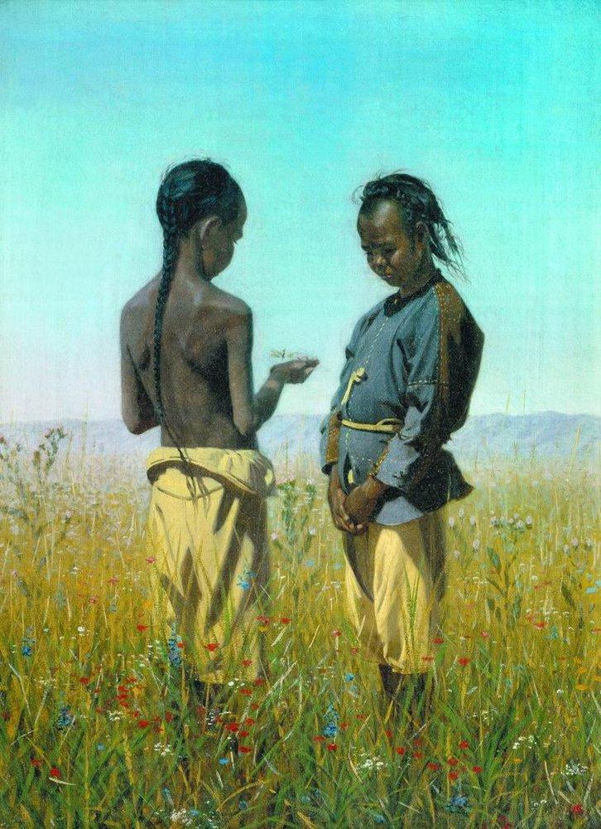

Children from the Solon tribe. Vasily Vereshchagin, 1876.
This place was full of life: the temporary huts of the Solons were here and there; near them, there were dirty women in Chinese shirts, the naked children were baking in the sun, while the husband, who was covered only with a hat, in long underwear, was beating rain sitting on a horse and pulling a harnessed dolly. Their strings of carts were also driving along the road. Their huge carts with two giant wheels, filled up with various stuff, deeply dug up the sandy road, leaving a wheel track not disappearing until a heavy rain. The driver, sitting on a driving box like a strange Chinese mushroom, speeded the horse with a long stick and produced a wild long sound: «Uhu… uhu…». Sometimes we met gigs filled with passengers, from 6 to 10 persons, with 6 or 7 horses harnessed: one was always at the root, and others were harnessed in front of the first one.

We almost got lost: it was impossible to see behind the trees where our fellows encamped. Here we started to view the surrounding area. To the left, very close to the road, there was a hilly ridge; to the right, in the distance, a wide ribbon of Ily was visible, and near it, the silhouettes of cities and surrounding groves showed dark. It was the city of Turgen-Kent, located at the inflow of the river Borokhudzir into Ily. [21] Ahead of us, the trees growing along the canals and the river banks showed up colorfully, and quite densely, near the Ily, they were beginning to thin, and, finally, disappeared at all, so that the angle formed by the inflow of Usek into Ily, was an open steppe. On the other hand, near the Ily itself, there were thick and dark forests. While we were looking through the spy glasses and finding white spots of the city walls in the distant groves, one of our Kyrgyz saw our white yurts between the trees. We whipped our horses, and literary rushed to our camp, consoling ourselves with the prospect of a long rest. Our yurts were set up between the elm bushes and thick willows; there was a canal near surrounded by the dense greenness of flowers. The camels, relieved from their packs, were dozed lazily, and the horses, released for feed, shook their manes, as if not believing their happiness and wanting to test whether the two-legged torturers were still sitting.
After the exhausting hot day full of labor, it is especially pleasant to lie in a yurt in a cool evening in loose clothes, or, what is better, without them, and, having raised a felt around the yurt for a free flow of wind, rest. It is a kind of supreme pleasure that is not available to everyone. The mere recollection of the past and the experienced aggravates it a hundredfold. One thing is annoying: mosquitoes, flies, and other gnats do not allow to enjoy steppe comfort and get pleasure. I don't remember why, but that evening remained in my memory for its extraordinary pleasantness, like our camp at Kudorg during the Issyk Kul expedition.
There was something especially pleasant and comforting in nature itself. It was not cold or hot: a moderate blessed mean, clean air, pleasant views, and finally, this in the very location of our camp, raised, almost through grills of the white yurts, crowds of Kazaks with pipes near the yurts and around, Kyrgyz cooking a tostik (brisket) over the fire or bustling around the cauldron of meat. The Kazaks rest under the trees, in various positions, throwing several greatcoats on branches for shade. Near them, there are stakes stuck in a cone, rifles of bipods, and ammunition scattered around. Near the detachment's belongings, sacks of flour, and various bags, the guard walked lazily [22] and looked enviously at the resting comrades. The camels lay in a row, chewing the cud, and a blue wisp of steam rose from their heavy breathing and sweat. Between the bushes, hobbled horses grazed, jumping with their whole bodies to go further. This whole picture was lit with bright, marvelously pink light of the setting sun; water, leaves on trees, flying beetles, flies, mosquitoes - all this shone and glowed with the same color.
The heat weakened, and nature revivified. The air was filled with the noise of a thousand various insects, birds sitting on the willow branches were singing… I heard the cries of geese, ducks, and quails in the neighboring fields. A noisy, busy life, full of fun, began everywhere [23] - a life opposite to the dead silence of the day. The evening brought our Chinese, who were sleeping under the tree like rocks for all this time, to senses.
Dulay came again with a friend and brought two rams and rice again. In Tatar language, laconically as usual, he “smelled” the health of the big man and began to prove again that the gifts must be taken. Here is a sample of his Jangolism for curiosity: big man... the way is long... ask… slept well. Jian-jn and hebe-amban…, say… big man… yusun bar (it is a custom), there are rams…, there is rice, there is something. The white tsar, Khuan-di hamitu chitande… equal, friend… When doing this, he folded two fingers and said: «Shu yanzi» (Shu is a Tatar word for "here," yanzi is a Chinese word for "kind." Of similar kind), and finished: «Go, big man … say... yusun bar – it is a custom!» For those who know the Tatar language, it would be helpful to give their own remarkable original samples of Chinese speech:
This time, dulay's pressure was respected for the last time: we had many own rams, and, having taken the gifts, we had to gift them too. The officials were so pleased with this acceptance that started to daringly drink the rum that we offered them and got drunk to such an extent that they began to explain their favor and friendship, expressing it especially strongly by folding two thumbs straight.
Dunchi, their interpreter, offered us to sing our song and just asked the permission of the officers. At first, the officials, acting according to etiquette, did not want to, but then they themselves began to sing along with the singer. Dunchi sang in Kalmyk, in Tarachi, and, finally, sang an improvisation in Kyrgyz. The solons live together with the Kyrgyz and know the Tatar language well. All night long, we could hear the creak of a cart, singing of Kalmyks and Solons, and their amazing coachmen cry. The Chinese sing quite pleasant.

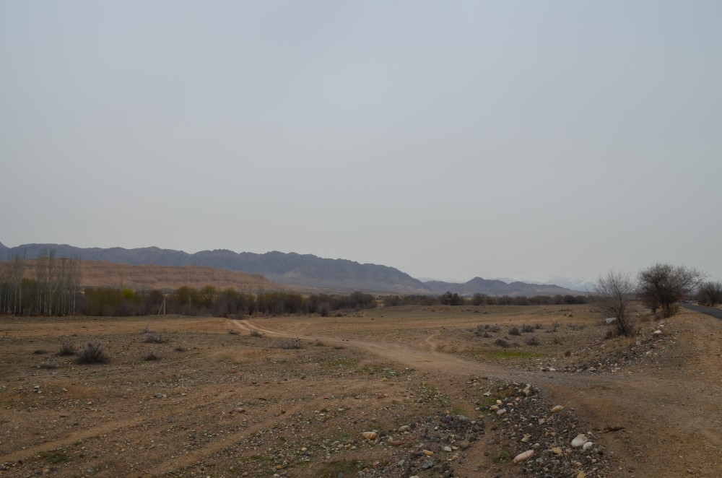

The steppe in front of the river Borokhudzir, March 2018

Usek Valley, March 2018

Old elm tree on the bank of Borokhudzir. At the time of Valikhanov's trip, this tree was already over a hundred years old. It is funny that Valikhanov, Kazakh, uses the name elm, and not the Turkish "karagach" or "vyaz", more familiar to Russians.

